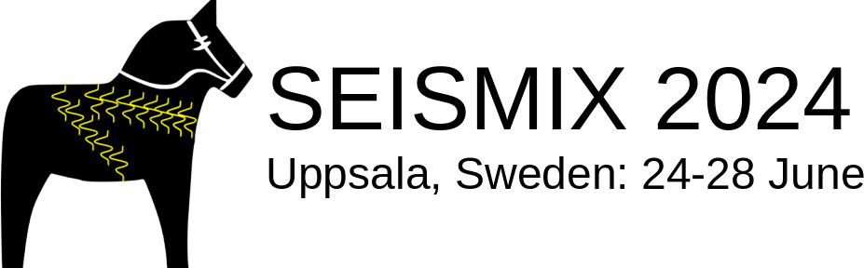Title, maximum two lines (use format style Title)

Authors in format: Anders A. Anderssona, Bodil B. Bodilsdotterb and Charlie C. Chaplinc (use format style Authors)

Affiliation in format: aOrganization xxxxx, country, e-mail; bOrganization yyyyy, country, e-mail; cOrganization zzzzz, country, e-mail (use format style Affiliation)

Write abstract text here. (Use format style Main text). Citations included in abstract should look like this: (Andersson et al. 1880, Carlsson 1956, Chaplin & Melin 2005) or ‘according to Nilsson (2004) and Vine & Matthews (1963)…’

Abstract limited to a single page! Submit to abstracts@seismix2024.se

# References (format style Heading)

Vine, F. J.; Matthews, D. H., 1963. Magnetic Anomalies over Oceanic Ridges. *Nature* *199*, 947-949. (Use format style Reference)